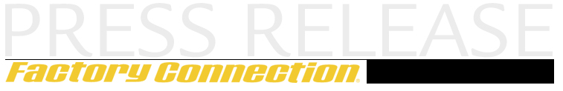
June 17, 2009
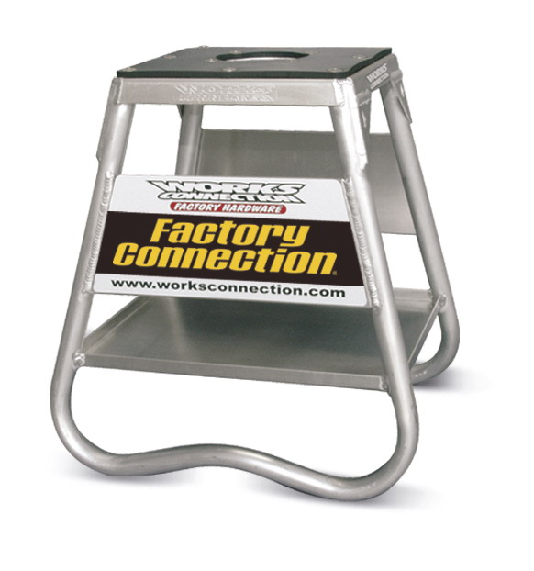

Trackside Support

STIMILON CHALLENGE

June 20-21, 2009
Factory Connection is pleased to be a sponsor and welcome back the Stimilon Challenge race. We will have staff on hand to help all riders tame the MX 338 track and any conditions that may be thrown at you!
FREE bike set up and technical support. The professionals at Factory Connection will help you tune you suspension and dial it in for your needs.
Take advantage of this great opportunity and experience ….
THE BEST SUSPENSION and SUSPENSION SERVICES. PERIOD!
SPECIAL STIMILON RACE WEEKEND OFFER
OIL CHANGE SERVICES $60 Forks / $60 Shock (Save $35 per set)
REBUILD SERVICES $175 + parts forks/shock complete ($68 savings)*
* wear parts are not included in Rebuild service price, varies based on condition.
Do you have a fork or shock seal leaking? Suspension in need of a service or springs changed to fit your riding weight / ability? Oil Change & Rebuild Services, Fork / Shock spring changes will be available at the track
See you at the ‘wick!

For more information, please contact: Steve Ross 800-221-7560 sales@factoryconnection.com
9 Commerce Way. Barrington, NH 03825 www.factoryconnection.com

